TV pro Assignment

- Please go to my website to review the Canon EOS Rebel T5i instruction manual, then label each part of the camera.
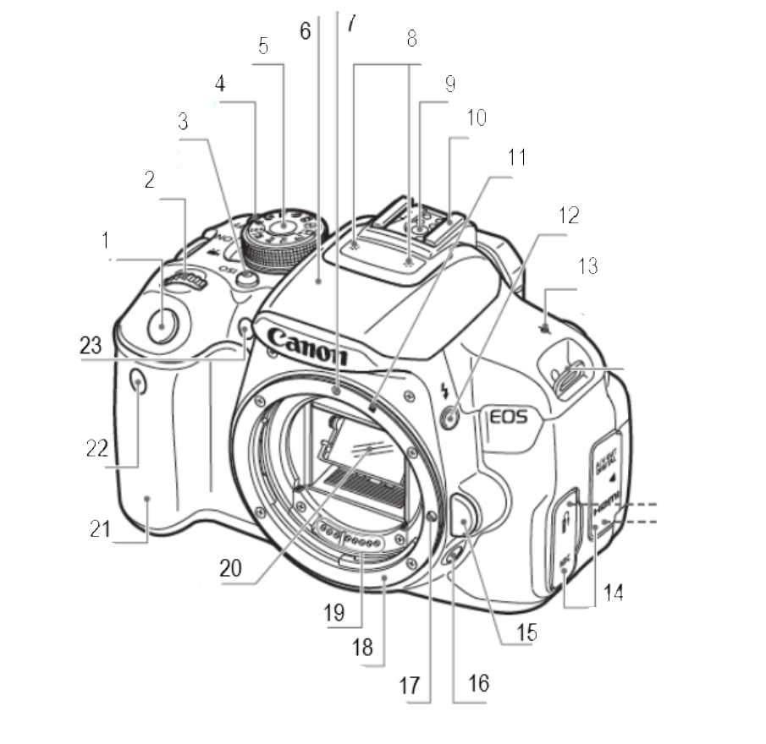

1 |  | 2
3 |  | 4
5 |  | 6
7 |  | 8
9 |  | 10
11 |  | 12
13 |  | 14
15 |  | 16
17 |  | 18
19 |  | 20
21 |  | 22
23

- Click the link: https://www.youtube.com/watch?v=2tyNdNZm_AQ

Once you finish watching, please write down 10 things you’ve learned:

1
2
3
4
5
6
7
8
9
10

