Script sample:

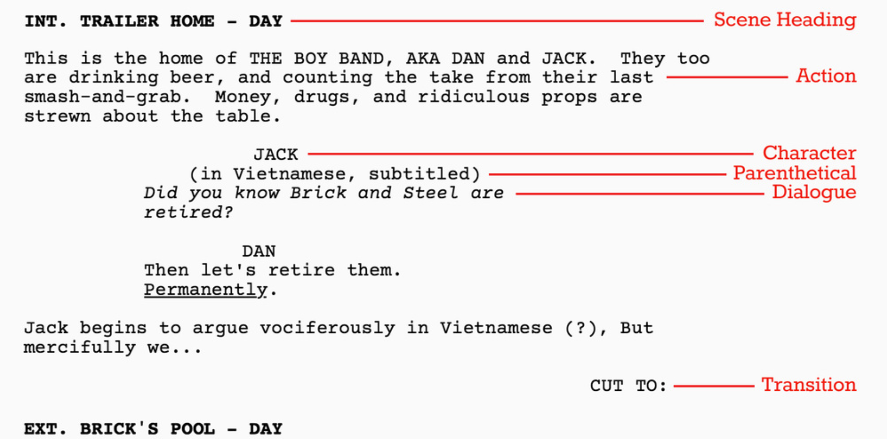
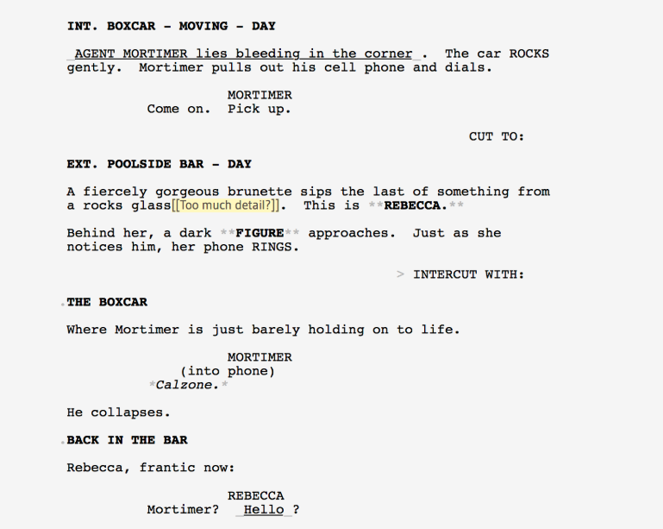

For one of the main locations in your screenplay, establish the mise en scene. Draw everything aside from the characters that would ideally be onscreen. Think: what is in the space, what is needed, and what will add meaning and help tell my story? Write down the professional script as a script sample shown on the other side of the page.

